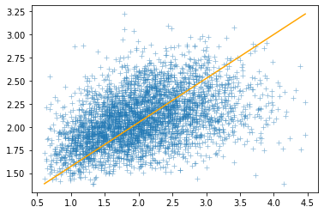

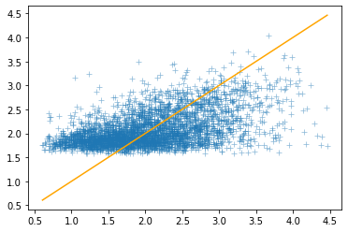

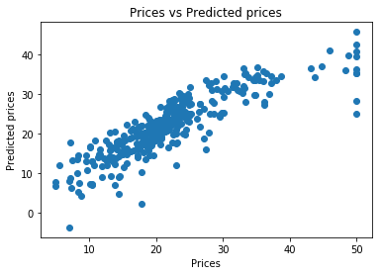

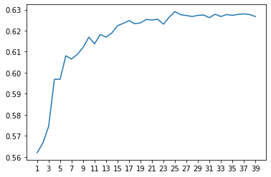

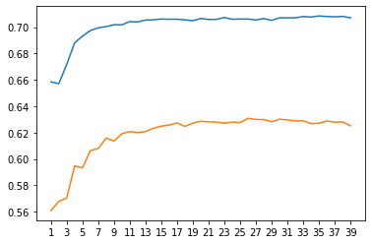

## Welcome to GitHub Pages

You can use the [editor on GitHub](https://github.com/favourumeh/Portfolio/edit/gh-pages/index.md) to maintain and preview the content for your website in Markdown files.

Whenever you commit to this repository, GitHub Pages will run [Jekyll](https://jekyllrb.com/) to rebuild the pages in your site, from the content in your Markdown files.

### Markdown

Markdown is a lightweight and easy-to-use syntax for styling your writing. It includes conventions for

```markdown

Syntax highlighted code block

# Header 1

## Header 2

### Header 3

- Bulleted

- List

1. Numbered

2. List

**Bold** and _Italic_ and `Code` text

[Link](url) and ![Image](src)

```

For more details see [GitHub Flavored Markdown](https://guides.github.com/features/mastering-markdown/).

### Jekyll Themes

Your Pages site will use the layout and styles from the Jekyll theme you have selected in your [repository settings](https://github.com/favourumeh/Portfolio/settings/pages). The name of this theme is saved in the Jekyll `_config.yml` configuration file.

### Support or Contact

Having trouble with Pages? Check out our [documentation](https://docs.github.com/categories/github-pages-basics/) or [contact support](https://support.github.com/contact) and we’ll help you sort it out.

Correlation heatmaps showing the transition from 12 numeric independent variables to 3

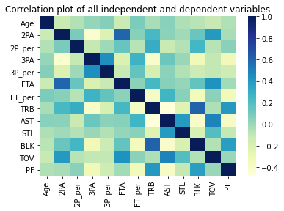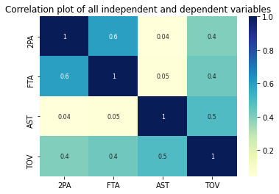

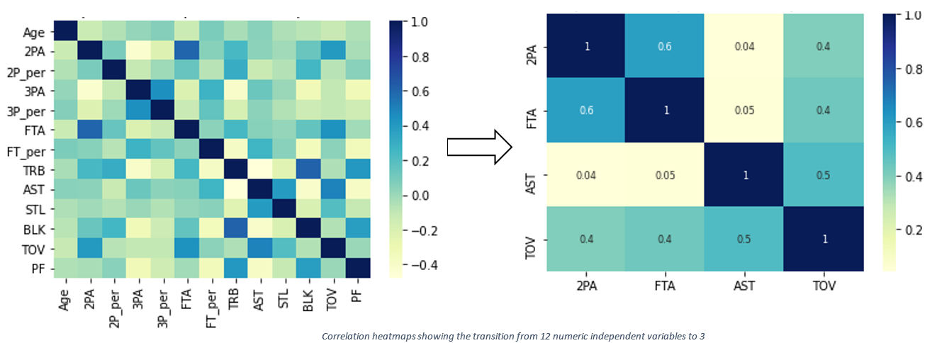

Figure 1: Correlation heatmaps showing the transition from 12 numeric independent variables to 3



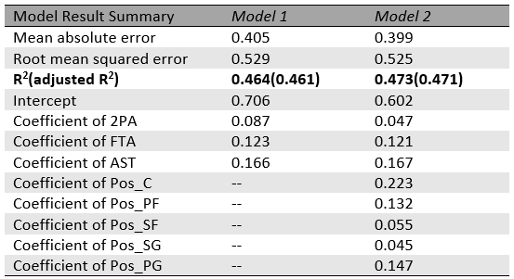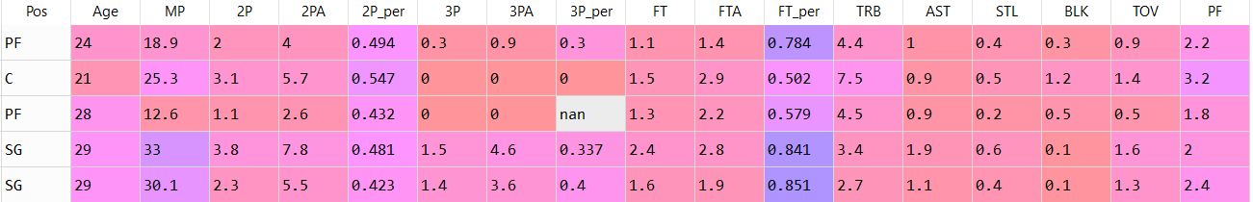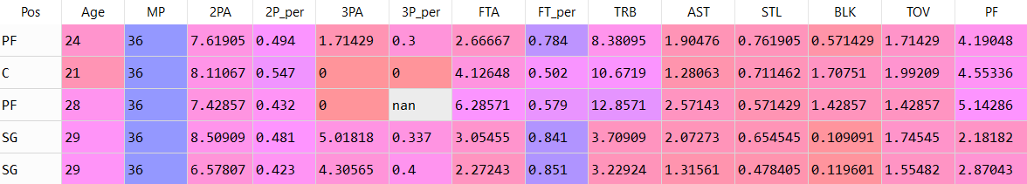

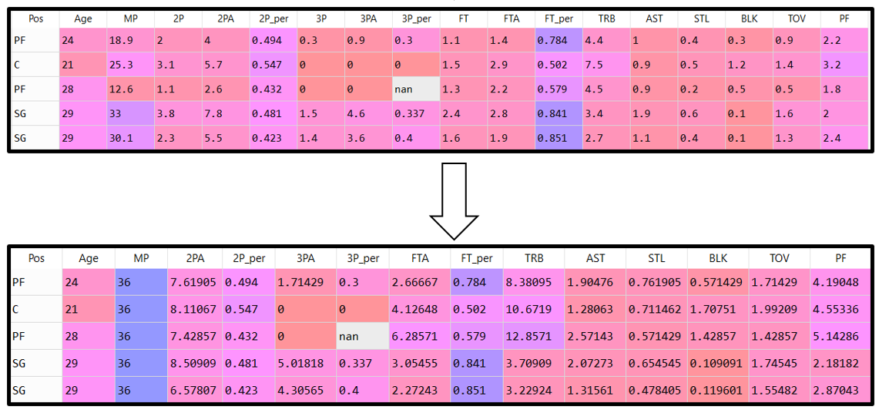 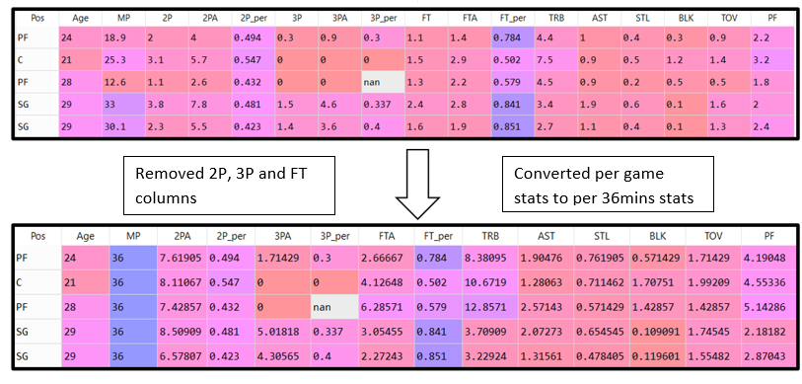

Converted per game stats to per 36mins stats

Removed 2P, 3P and FT columns

- (Homoscedasticity, No Autocorrelation, Normal Residuals, No Multicollinearity, Exogeneity)

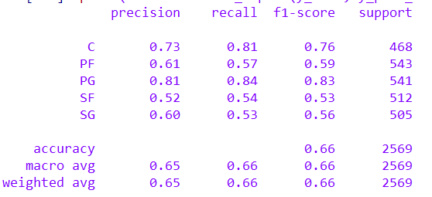

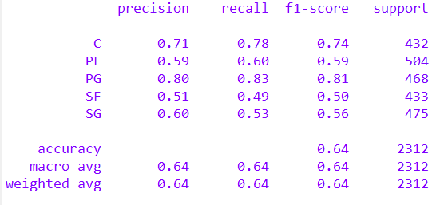

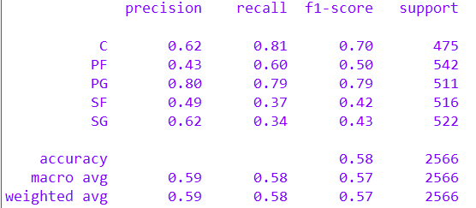

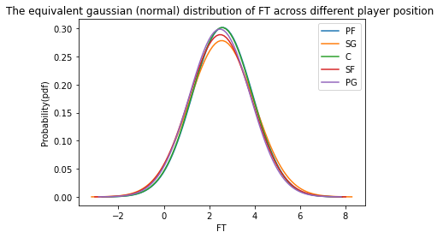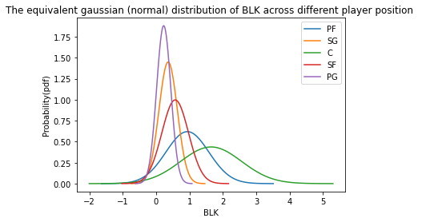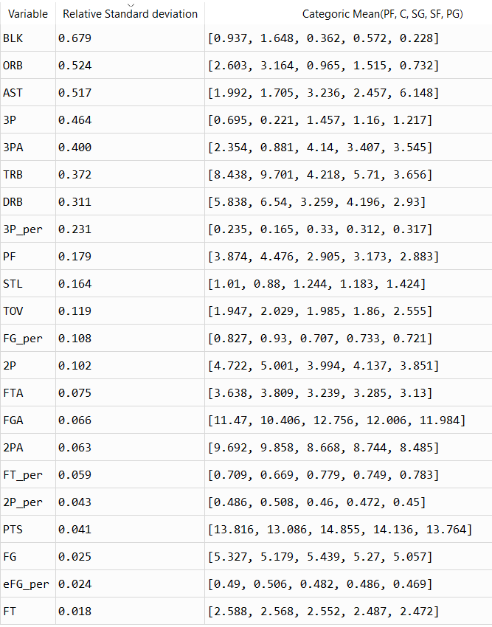

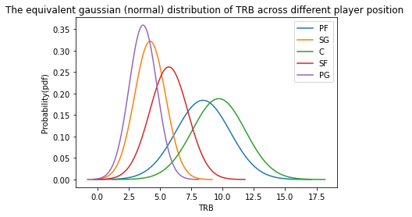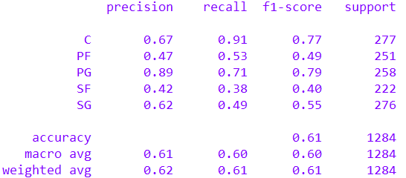

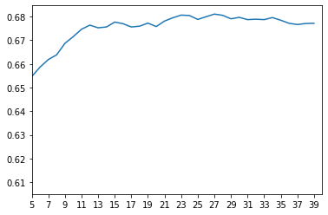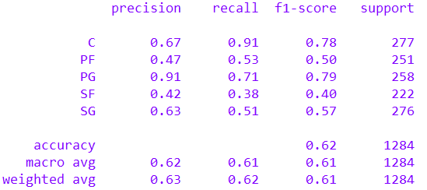

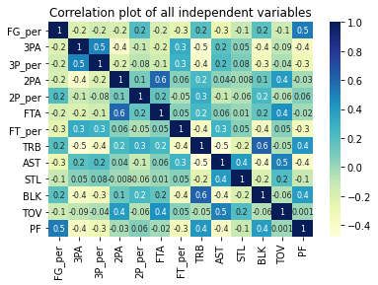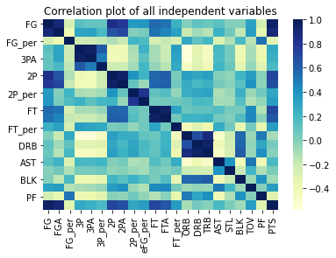

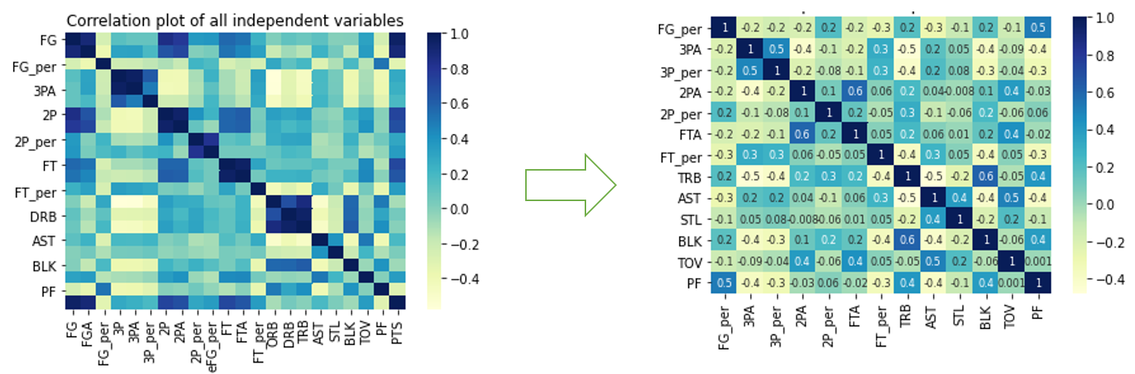

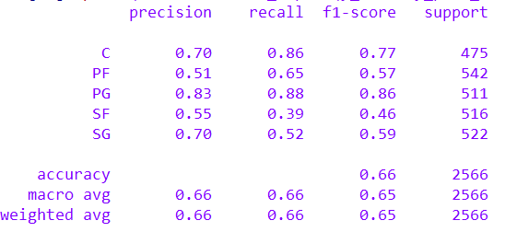

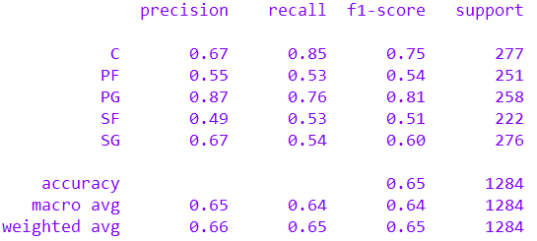

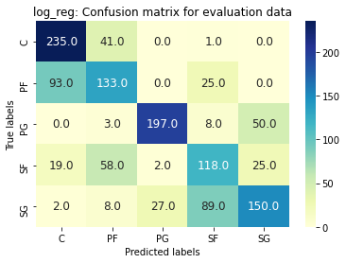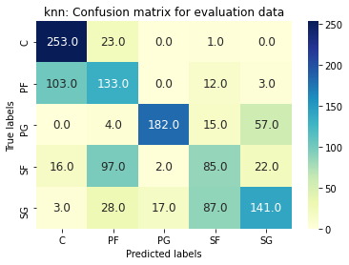

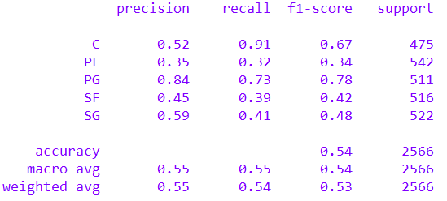

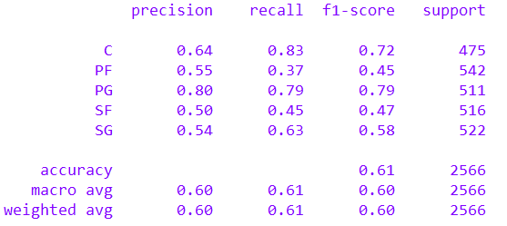

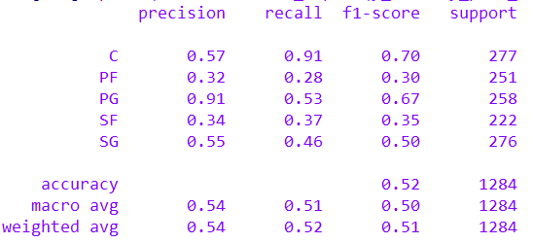

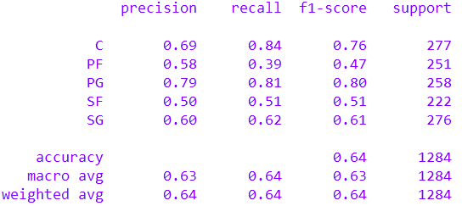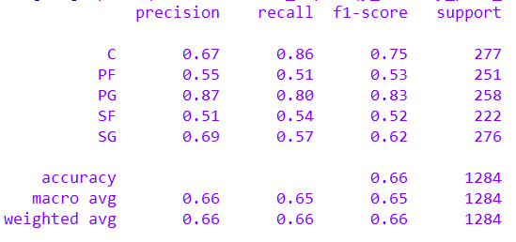

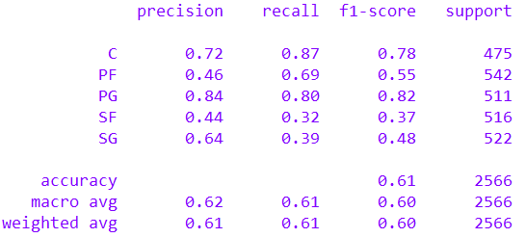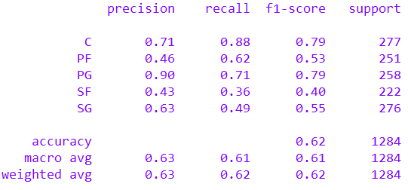knn

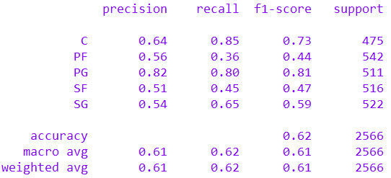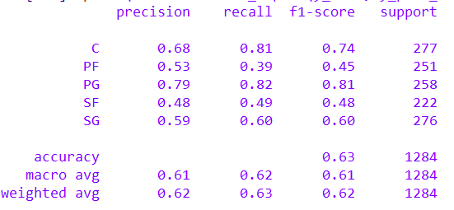GNB

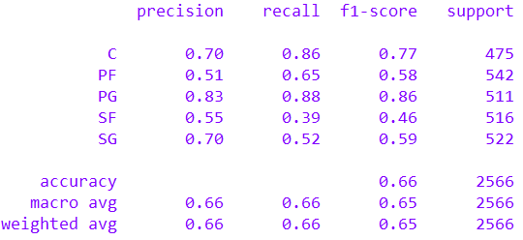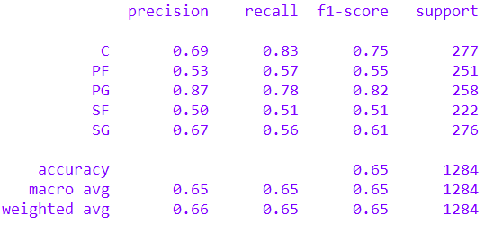

Analysing test data classification tables

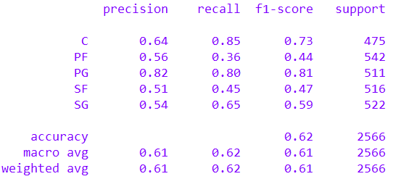

Figure 2: GNB

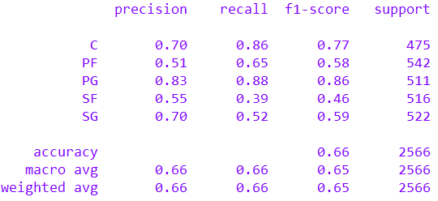

Figure 3: Log_reg

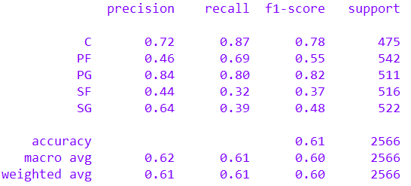

Figure 4: KNN

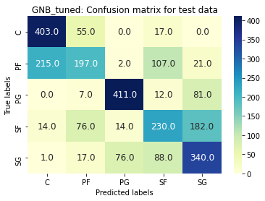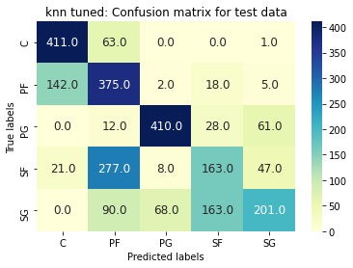

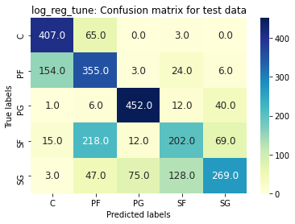

Voting system Results

1. System 1: Hard voting 1.0

* Majority wins in a 2-1 voting split
* For ‘hung parliament’ scenario(3-way voting split) then randomly select a model’s prediction
* Test data Results

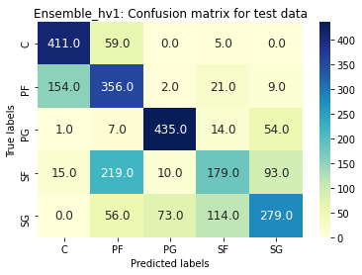

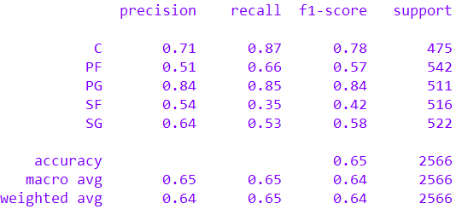

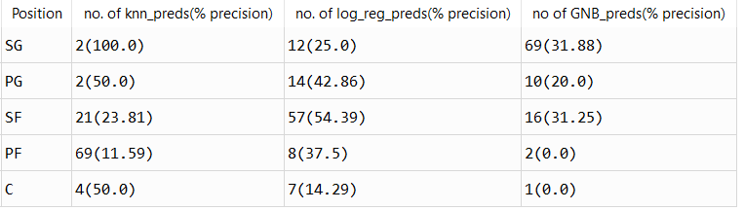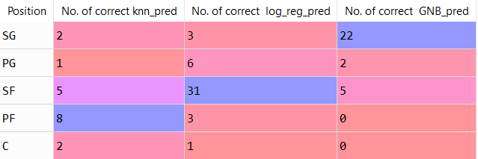

1. System 2: Hard voting Flex (Playing the odds)

* Majority wins in a 2-1 voting split for the most part
* For 2-1 cases where KNN and Log_Reg agree on a player being a PF
* For ‘hung parliament’ scenario(3-way voting split) then select with the model with the highest precision for the hung cases

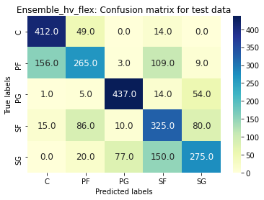

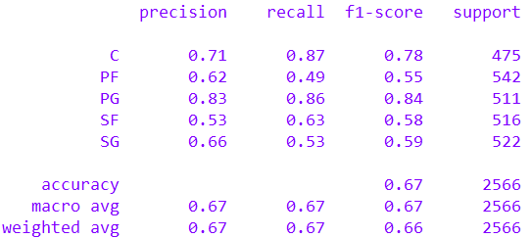

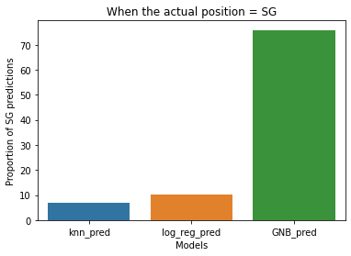

Figure 7: The accuracy of different models for the hung parliament scenario where the actual position = SG

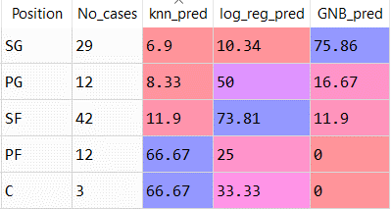

Figure 6: Accuracy of prediction for different labels in hung parliament cases

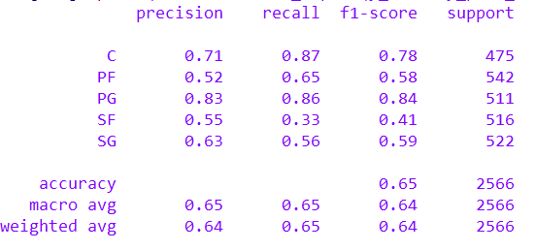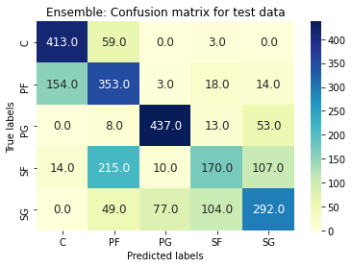

Figure 8: initial hierarchy



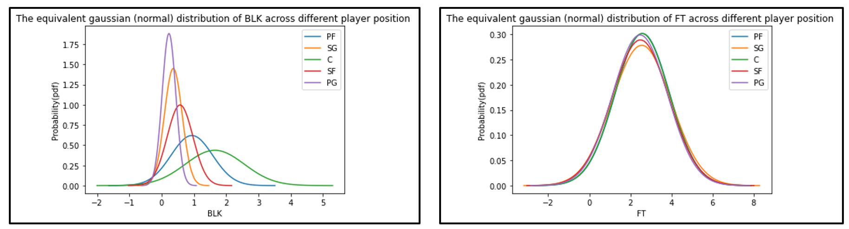

**RSD= 0.679**

**RSD= 0.018**

**Relative Standard Deviation: 0.679**

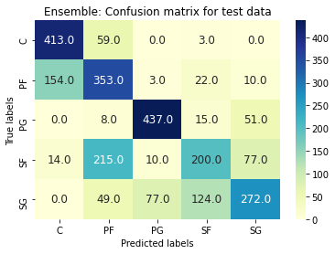

Figure 9: improved hierarchy-- log_reg_PF takes precedent over GNB_SG

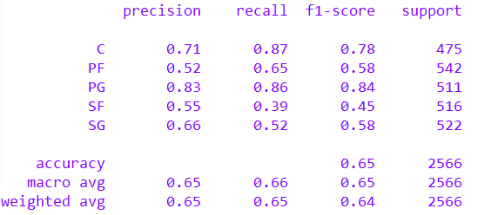

Figure 10: improved hierarchy-- log_reg_PF takes precedent over GNB_SG

